# **8 ways to get the most out of your Pelican Pool Hoist**

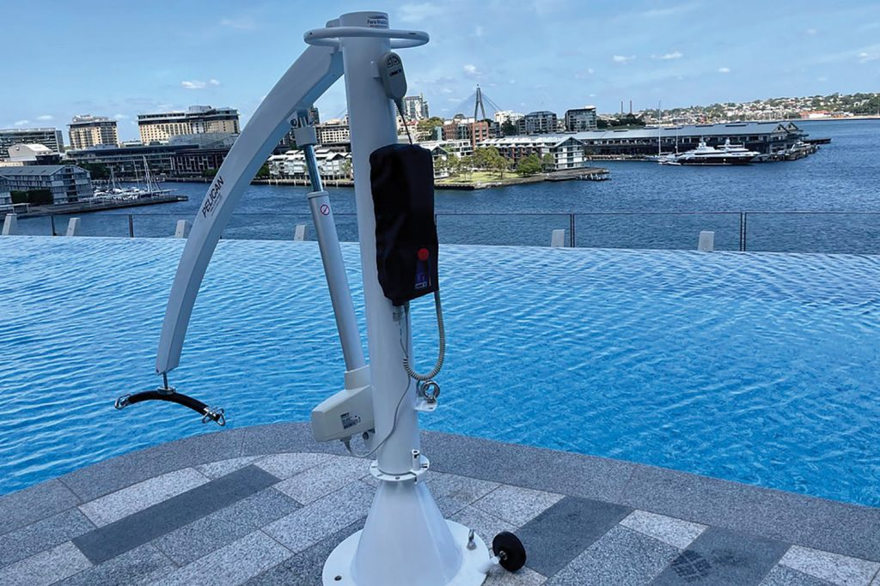

## Quick tips to maximise the benefits and functionality of your Pelican Pool Hoists

#### Proper Installation:

Ensure the Pelican Pool Hoist is installed correctly according to our instructions and local regulations. Proper installation ensures safe and efficient operation.

#### Regular Maintenance:

Schedule [regular maintenance](https://paramobility.com.au/service-form/) checks to ensure your hoist is always in good working condition. Inspect for any signs of wear or damage and address any issues promptly to prevent malfunctions.

#### Training:

Provide thorough training to staff members or caregivers who will be operating the hoist. Ensure they understand how to use the hoist safely and effectively, including proper positioning of the user and securing the straps.

#### Accessibility:

Make sure the Pelican Pool Hoist is easily accessible to users. Position it in a convenient location near the pool edge, with clear pathways for wheelchair users or individuals with mobility aids to access the hoist.

#### User Support:

Offer assistance and support to users who may require help using the hoist. Ensure staff members are available to assist with transfers and provide guidance as needed.

#### Clear Instructions:

Display clear and easy-to-follow instructions for using the hoist near the pool area. Include diagrams or illustrations to help users understand the proper operation of the hoist.

#### Safety Equipment:

Keep safety equipment, such as life rings or flotation devices, nearby in case of emergencies. Ensure staff members are trained in water rescue techniques and can respond quickly if needed.

#### Feedback:

Encourage feedback from users to identify any areas for improvement or suggestions for enhancing the hoist’s usability. Address any concerns or issues raised by users promptly to ensure their needs are met. If nothing else, it’ll help build a relationship with your users.

By implementing these tips, you can ensure that the Pelican Pool Hoist is used safely and effectively, allowing individuals with mobility challenges to access the pool with confidence and ease.

Source: [Para Mobility](https://www.paramobility.com.au/)

[](https://paramobility.com.au/)